Association of Southeast Asian Nations (ASEAN)
(Updated: Feb 2022)
About:
- It is a regional grouping that promotes economic, political, and security cooperation.
- It was established in Aug 1967 in Bangkok, Thailand by the founding fathers of ASEAN, namely Indonesia, Malaysia, Philippines, Singapore and Thailand.
- Its chairmanship rotates annually, based on the alphabetical order of the English names of Member States.
- ASEAN countries have a total population of 650 million people and a combined Gross Domestic Product (GDP) of USD 2.8 trillion. It is India’s 4th largest trading partner with about USD 86.9 billion in trade.
Members:
ASEAN brings together ten Southeast Asian states – Brunei, Cambodia, Indonesia, Laos, Malaysia, Myanmar, the Philippines, Singapore, Thailand and Vietnam – into one organisation.
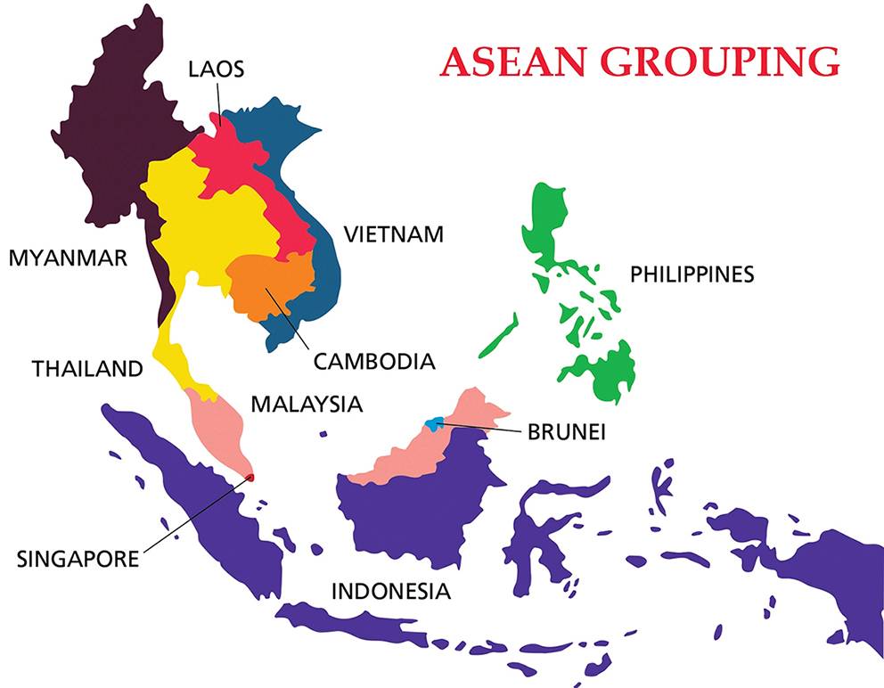

India’s Indo-Pacific Oceans Initiative (IPOI)
- It is an open, non-treaty-based initiative for countries to work together for cooperative and collaborative solutions to common challenges in the region. .
- It focusses on seven pillars:
  - Maritime Security
  - Maritime Ecology
  - Maritime Resources
  - Capacity Building and Resource Sharing
  - Disaster Risk Reduction and Management
  - Science, Technology and Academic Cooperation
  - Trade Connectivity and Maritime Transport

Why in News
In Oct 2021, India participated in the 18th India-ASEAN Summit at the invitation of Brunei, the current Chair of ASEAN.
- The Year 2022 has been highlighted as India-ASEAN Friendship by the leaders.
- India-ASEAN Summit is held every year and provides an opportunity for India and Asean to engage at the highest level.

Key Points
ASEAN in Act East Policy:
- The centrality of ASEAN in India's Act East Policy and in India's Vision for the wider Indo-Pacific Vision has been underlined.
- Welcomed the adoption of the India-ASEAN Joint Statement on cooperation for peace, stability and prosperity in the region, building upon the synergies between the ASEAN Outlook for the Indo-Pacific (AOIP) and India’s Indo-Pacific Oceans Initiative (IPOI).
- Recently, India also addressed the 16th East Asia Summit, where it reaffirmed India's focus on a free, open and inclusive Indo-Pacific and the principle of Asean Centrality in the region.

India-ASEAN Connectivity:
- Exchanged views on enhancing India-ASEAN connectivity, including physical, digital and people to people.
- India announced its support for establishing the ASEAN Cultural Heritage List to further strengthen India-ASEAN cultural connectivity.
- Trade and Investment:
  - The importance of diversification and resilience of supply chains for post-Covid economic recovery and in this regard, the need to revamp the India-ASEAN Free Trade Agreement (FTA) has been underlined.

- Covid-19:
Highlighted India’s efforts in the fight against the pandemic in the region.
- India has contributed medical supplies worth USD 200,000 to ASEAN’s humanitarian initiative for Myanmar and USD 1 million for ASEAN’s Covid-19 Response Fund.

India-ASEAN and China
- Traditionally the basis of India-ASEAN ties has been trading and people-to-people ties due to shared historical and cultural roots, a more recent and urgent area of convergence has been balancing China’s rise.
- Both India and ASEAN aim to establish a rules-based security architecture for peaceful development in the region, in contrast to China’s aggressive policies.
- Like India, several ASEAN members such as Vietnam, the Philippines, Malaysia, and Brunei have territorial disputes with China, the China factor does form an important component of the relationship.
- India in 2014 reinvigorated the Look East policy into Act East Policy, with a more strategic outlook than its previous incarnation, focusing on engagement not just with Southeast Asian countries but also those in the Pacific.

